Group-25 SmallBizz Navigator

Satya Vara Prasad Namala(Team Coordinator)
Bonam Venkata Sri Sai Kanaka Raju
Goparaju Vijay Venkatrao
Bala phaneendra pothuri
Laasya Madige

INFO 5707 Data Modeling
Dr. Tozammel Hossain

Project Description

The SmallBizz Navigator is a versatile tool designed specifically for small enterprises, aiming to accomplish the following goals:

Operational Efficiency:
Streamlining operations by automating repetitive tasks for time savings.
Enhancing the efficiency of day-to-day operations management.

Financial Simplification:
Simplifying the tracking of financial transactions.
Generating reports to facilitate budget analysis and planning.

Customer Relationship Management (CRM):
Centralizing customer information for improved communication and relationship-building.
Enhancing customer interactions through streamlined processes.

Inventory Optimization:
Optimizing stock levels to prevent excess or shortages.
Tracking inventory movements to improve planning.

Sales and Marketing Assistance:
Assisting in sales activities and order management.
Providing tools for executing effective marketing campaigns and customer acquisition.

Efficient Employee Management:
Aiding in human resource tasks such as payroll and leave management.
Monitoring employee performance and fostering professional development.

Analytics and Reporting Insights:
Offering valuable insights through analytics and reporting features.
Empowering data-driven decision-making for enhanced business strategies.

Compliance and Regulation Support:
Assisting businesses in adhering to legal and regulatory requirements.
Facilitating tax compliance and reporting processes.

Scalability and Adaptability:
Supporting business growth through scalable solutions.
Adapting to the evolving needs of an expanding enterprise.

User-Friendly Interface and Training:
Providing an intuitive and user-friendly interface.
Offering comprehensive training and support for users.

Data Security and Privacy Assurance:
Ensuring the utmost security and privacy of business data.
Implementing robust measures to prevent data breaches.
Mobile Accessibility and Remote Work Support:

Enabling users to access key features on various mobile devices.
Supporting remote work initiatives for enhanced accessibility.

Integration with Third-Party Tools:
Seamlessly integrating with other tools and services to augment functionality.
Ensuring compatibility with widely used business applications.

Cost-Effective Solutions:
Providing affordable solutions tailored for small businesses.
Delivering substantial value for the investment in the software.

Objectives
SmallBizz Navigator is a tool made specifically for small businesses, having the following objectives in mind:
  - Saving time by automating repetitive chores.
  - Improving the effectiveness of daily operations management.
  - Making financial transaction tracking easier.
  - Producing reports to support planning and budget analysis.
  - Keeping an organized database with client data.
  - Strengthening connections and enhancing customer communication.
  - Improving stock levels to prevent shortages or overstocking.
  - Monitoring inventory movements to improve the planning process.
  - Helping with order management and sales activities.
  - Offering marketing resources and supporting the acquisition of new clients.
  - Assisting with payroll and leave administration duties related to human resources.
  - Tracking and assessing the development and performance of employees.
  - Providing insights via reporting and analytics tools.
  - Facilitating decision-making based on data.
  - Helping companies comply with legal and regulatory obligations.
  - Making tax reporting and compliance simpler.
  - Being scalable to support the expansion of businesses.
  - Changing to meet the changing demands of a developing business.
  - Offering an interface that is simple to use and intuitive.
  - Providing users with assistance and training.
  - Making sure that company data is secure and private.
  - Putting policies in place to stop data leaks.
  - Enabling consumers to utilize mobile devices' essential features.
  - Promoting accessibility and remote work.
  - Connecting to additional services and tools to improve functionality.
  - Guaranteeing interoperability with frequently used business software.
  - Offering small businesses options that are reasonably priced.
  - Providing value in relation to the software's cost.

Scope

- our project will includes modules for the employee information, management, managing the recruitment process, to track the attendance, leave management, processing of individuals payroll, performance appraisal, project handling (task handling), employee salary, employee's benefits like medical and house rent .., small loans for their personal issues and a Todo list.

- Through our project the organization can handle the access levels and specific permissions for the employees and managers according to the wish of stake holders.

- there are certain requirements for the SBN where it will be interacting with the external devices like attendance taking machines (censors or any external inputs) and some other external software’s which will be using by the company for their productivity. for example, stocking software’s for their warehouses or some other software’s or any bank based portals for the management of salary and loans for their employees.

- The scope includes the data migration of the current employees data to the new SBN (same software but different physical address), giving us the seamless transfer of the data without any data loss or any discrepancies.

- the project will implement the security measure such as role-based access control as mentioned above, encryption of sensitive data like hiding the address and contact information of the employees and not disclosing them to other organizations and following some of the regular security audits. to protect the integrity and confidentiality of the employee’s information.

- the entire system will be built keeping future in mind that allowing to expand in terms of users (adding and voiding current), adding features and increasing the server’s capacity for increasing the data volume as the business grows.

- in future the SBN will gets to the users via mobile to giving them some of the features from the original one.

- The system is going to provide customizations on the wish of stake holders. that is to configure their workflows and some of the reports with the help of admin access.

- As part of the project scope full documentation, covering technical specification user manual, system architecture will be included to make maintenance and make upgrades easier in the future.

- The scope includes the re verifying and complete testing of the whole system in order to identify bugs or some other issues that ruins users experience and deliver our system error free systems.

- The project will be undergoing UAT (user acceptance testing) before the delivering of the project. It is nothing but testing the user interface of the system by some real users (now a days it is getting automated) in order to validate the stake holders’ requirements and expectations before the final delivery of the system.

Project Requirements
Operating System: Windows
Database: MySQL
Applications: MYSQL Workbench, Draw.io, Microsoft Word.

Database Requirements
The following is a list of different entities that we are going to use for our project.

- Employee table
- Employee_file
- Emp_assets
- Emp_experience
- Emp_leave
- owner
- Address table
- Attendance table
- Department table
- project
- pro_expenses
- to-do-list
- bank_info
- Assets table
- Assets_category

User Requirements
- generating a unique ID per employee and stores the information of the employee in not only a single table as the data is more.
- generating a unique id for the address info of an employee that shows the postbox information of the employee working in the organization.
- employees should be able to add, edit or view their own information and the system should support the process.
- The attendance of the employee should support the either way like manually entering the attendance and getting it via automated attendance system.
- The admin should have the ability to alter the attendance of the employees.
- Employees should be able to submit their requests asking for leaves.
- admin should receive the notifications and have their own powers, either to approve or reject the leave requests.
- admin should be able to calculate the payroll of the employee accurately.
- The system should be able to support the inclusion of the benefits of the employee like rental based, medical, conveyance and other finance related stuff.
- The system should be able to provide a project-based entity in order to organize the tasks.
- The system should allow admin to track the work progress of the employee.
- employees of the organization should have access to their personal information.
- the system should bind all the features effectively with external systems such as attendance tracking systems.
- admin should have the confidence about the security of the data.
- the system should implement encryption protocol in order to regular security audits.
- the interface of the system should be interactive in order to navigate through the system.
- The system should be designed in order to accommodate the future growth of features as well as data volume.

Business Rules
- Every employee has a unique employee id (emp_id).
- Only one employee may be connected to an account.
- employee can be identified by his unique emp_id.
- All new employees of the organization should complete their onboarding process by submitting their information regarding GOVT ID, picture, post box info etc...
- only the employees of the organization can create an account.
- employees themselves responsible for updating their personal info.
- for every address mentioned by the customer should be assigned by an id.
- To change any job titles and departments of a particular employee then it can only done by the Admin.
- certain rules for the leave request should be implemented like, leave request should be submitted or should inform prior to the date of leave.
- Approval of the leave request should be done by admin with in a time limit after the receiving of the leave request.
- multiple physical storages of the data should be stored on the organization’s personal computers only.
- Shifts for the employees should be limited according to the business days and collection of the organization.
- Total cash and the card payments of the entire business should be submitted to the admin by the end of the day.
- Assets of the organization should be maintained properly by the employees if not there should be a compensation for the damage.
- organization should not allow employees to use the assets for their personal use.
- loans should only be provided for the eligible employees.
- there should be a limit for the loan amount.
- attendance of an employee cant be altered by the employee himself.
- admin can alter the attendance of the employee.
- overtime of an employee should be recorded.
- every task that is assigned for an employee should have its id.
- every project should have its own unique project id.
- holiday for the organization should be declared priorly.
- employees neither use project files and their URLS for their personal use nor for any other organization.
- any illegal conduct by an employee can be informed to the police department right away.
- people that are working in the organization should follow the data privacy policies.

Entity Relationship Diagram (ERD)

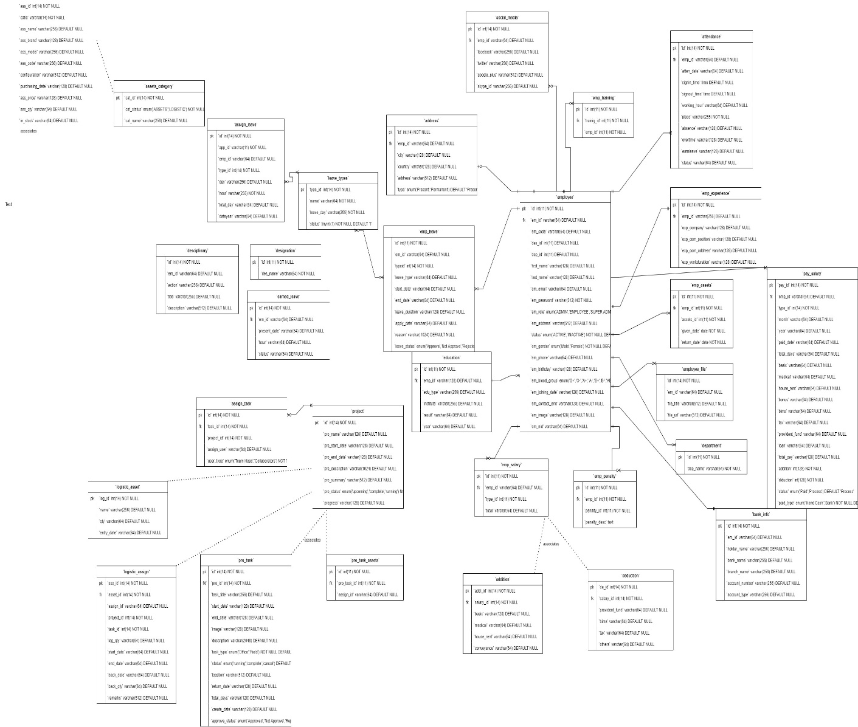

Table 1: Components of the ERM
Entity | Relation | Connection | Entity
Employee | Has | 1-1 | Address
Employee | Has | 1-1 | Emp_experience
Employee | Owes | 1-m | Emp_assets
Employee | Studied | 1-m | Education
Employee | Applies | 1-m | Emp_leave
Employee | Owns | 1-m | Emp_files
Employee | Pays | 1-m | Emp_penalty
Employee | Gets | 1-m | Emp_salary
Employee | Trains | 1-m | Emp_training
Employee | Have | 1-m | Social_media
Department | Have | 1-m | Employee
Assign_leave | Have | m-m | Leave_types
Assign_task | Have | m-m | Project
Emp_leave | Have | m-m | Leave_types

Table 2: Data Dictionary
